|  |  |  |  |  |
| --- | --- | --- | --- | --- |
| Anthony Nguyen | George Stergiadis | Artem Potemkin | Victor Heather | Sahil Mann |
| Position | | | | |
| *Brueno – Senior Software Engineer* | *Fire Rescue Victoria – System Analyst – Integration Platform* | *SpaceX – Network Engineer (Starlink)* | *IxD – UX Designer* | *CyberArk – Cyber Security Specialist* |
| Skills Required | | | | |
| ● Experience with writing clean, modular and maintainable Kotlin OR background in Java development  ● Experience with relational and NoSQL databases  ● Experience with RESTful APIs  ● Python or TypeScript | ● Computer science, information systems, or related degree  ● Extensive experience in designing and developing integration solutions  ● Well-developed interpersonal skills  ● Report writing ability  ● An integration solution design and development certification  ● ITIL framework (certification on Foundation level is preferred) | ● A bachelor’s degree in a technical or engineering sphere  ● Understand how networks work  ●Protocols that could be used  ●Different types of connectivity  ●Implementation of network security  ● Cisco, Juniper or other certification of this sort  ● 3 years of experience of working with and operating a service provider network | ● User Experience (UX) or Interactive Design experience  ● User psychology and critical analysis  ● Project Management (E.g. Time Management)  ● Design and Innovative Portfolios | ● Bachelor of Computer Science, information technology, or a related discipline  ● Some knowledge of the CyberArk security platform  ● At least 3 years of experience in the field  ● To be able to work independently and work in a team |
| Existing Skills | | | | |
| ● Some experience using SpringBoot for web-backend development  ● Python Flask  ● C and C++  ● Working with RaspberryPis and some of its sensehat features  ● Working in groups  ● Stepping up and leading some of the groups  ● SQL | ● Basic HTML and R programming  ● Slight understanding of DBMS’s  ● Ability to communicate clearly with a team and enjoy teamwork-based work | ● Working with networks  ● Working with and repairing computers  ● Visual Basic  ● Basic understanding of Python |  | ● Being able to work independently  ● Skills in working in a fast-paced environment |

**Analysis**

|  |
| --- |
| All our ideal jobs extend into the IT industry, which makes sense given that we are all studying this subject. In the IT industry itself, however, some of our jobs differ vastly, as the IT industry is a very big one and has vacancies for all sorts of different jobs. Our ideal jobs vary from engineers to UX designers, from system analysts to security specialists. Everyone, except for Victor, is required to complete an IT course to get their desired jobs and that’s the only thing we all have in common. In the IT industry there are countless different certifications, programming languages and skills that could be required. Some of us are required to code in different languages, others require specific certifications, while some would need existing work experience in the sphere.  Some of our existing skills, however, do match. That’s mostly about being able to code and our work ethics. That doesn’t come as a surprise as so far we haven’t been studying vastly different subjects. Most of us just came out of high school and just started this course, so it makes sense for us to have common existing skills. We do also have hobbies though that we learnt a lot from: from understanding of DBMS’s to working with Raspberry Pi’s.  Overall, we’re alike and different at the same time, but that’s most people in the IT industry. We are all currently learning the same things, we have a lot in common when it comes to things we’ve learnt in the past, but we are all putting more effort towards different aspects of this course and our IT interest as a whole. A lot of the same base knowledge is often required, however, more often than not, a lot of work specific knowledge is also necessary to get a position in the industry. |

**Anthony Nguyen**

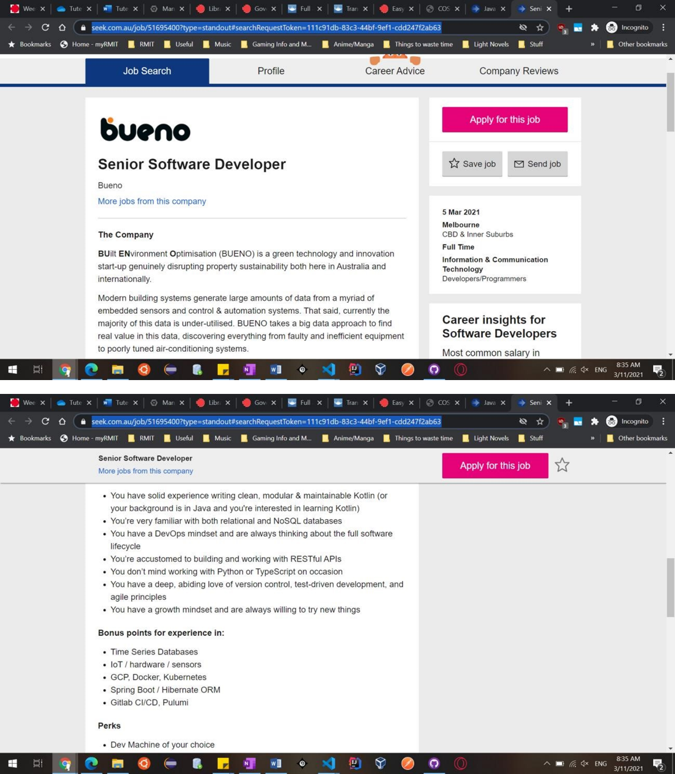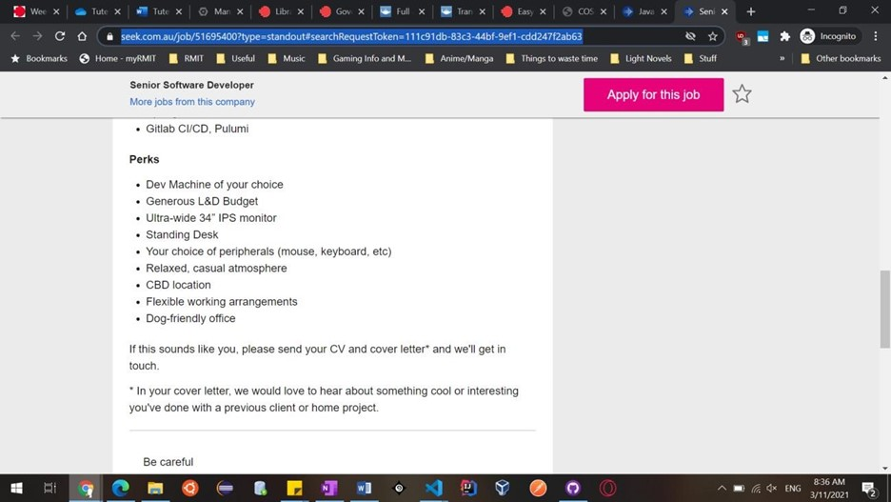

**George Stergiadis**



**Artem Potemkin**

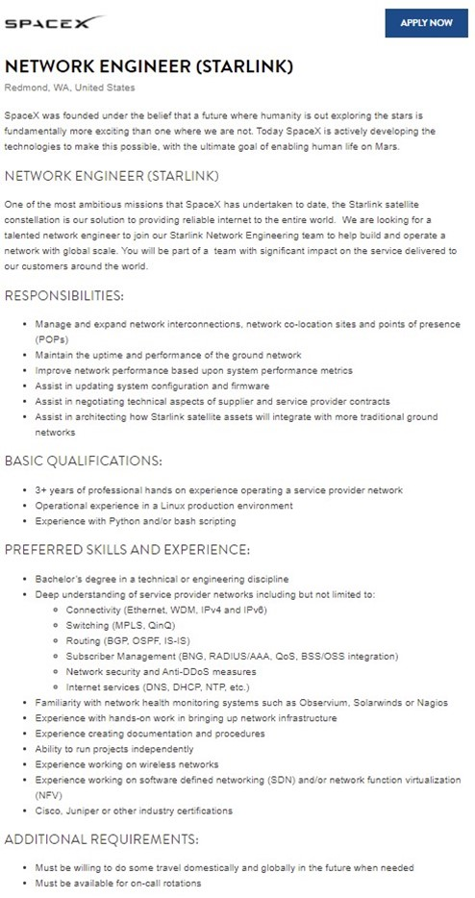

**Victor Heather**



**Sahil Mann**